Abstract

1. **Title of the Project** :Devastating Impact of Covid Pandemic
2. **Team members and Bio:**
3. **Datasets:** 
   1. Following data will be considered for studying the effect of COVID pandemic and number of deaths and number of cases in different countries : <https://github.com/CSSEGISandData/COVID-19> and <https://www.kaggle.com/datasets/imdevskp/corona-virus-report>

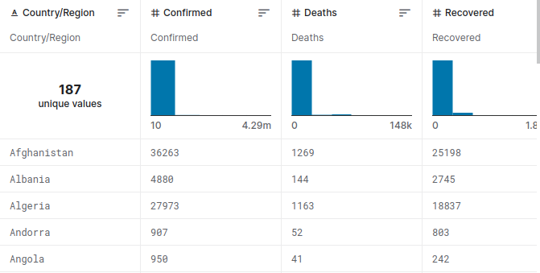

* 1. Similarly we will be working on some other datasets as well like: <https://www.kaggle.com/datasets/josephassaker/covid19-global-dataset> for studying impact of COVID pandemic.

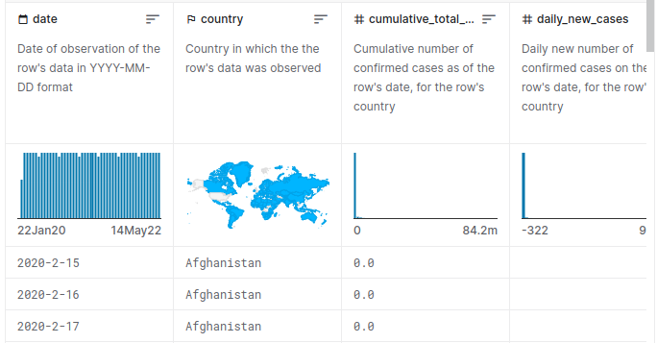

* 1. Next we will be doing text based data study using <https://github.com/UBC-NLP/megacov> as our primary data source.

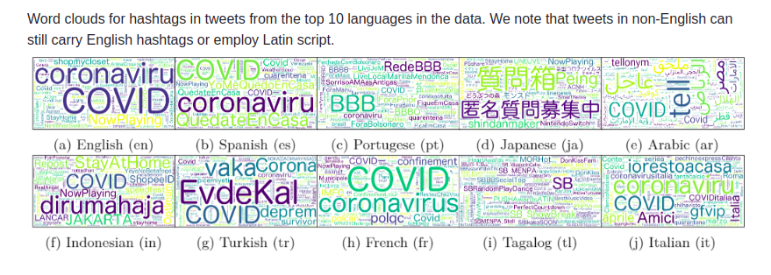

* 1. For the dataset related to job market, we will be using <https://www.kaggle.com/datasets/vineethakkinapalli/impact-of-covid19-on-employment-ilostat> and <https://healthdata.gov/dataset/Loss-of-Work-Due-to-Illness-from-COVID-19/96kt-bzs4>

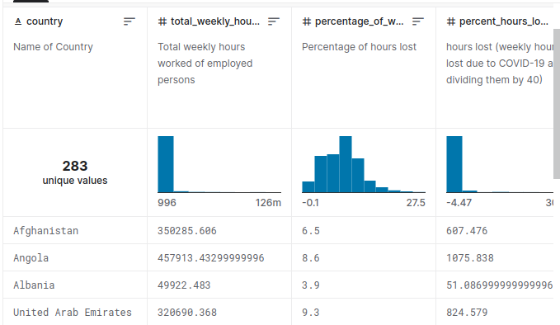

4.**Purpose**

We will be studying the impact of Covid pandemic and its effect on various countries. We will be fetching data through various services and making relevant data preprocessing to get clean data and then finding out some of the information such as total mortality, number of infected people, impact on tech companies and other jobs and services. Overall goal will be to study the impact of Covid pandemic and its overall impact on human beings.

**Our primary goal will be:**

1. To analyse the data and study the impact of covid on health and job market
2. To present the results in clear way so that results can be understood clearly,

**5. Steps and outlines**

1. Fetching the database
2. Cleaning the data, removing null values, etc.
3. Making relevant preprocessing steps
4. Identifying most/worst affected parties
5. Presenting the results in clear way

**6. Whether machine learning models can be used or extended**

> Some of the variables can be studied and can be predicted using machine learning models specifically using supervised learning approaches.

> Natural language processing can also be used for some of the textual data analysis purpose.